**Login using SSH with AWS Using Putty**

1. Launch the new instance in EC2

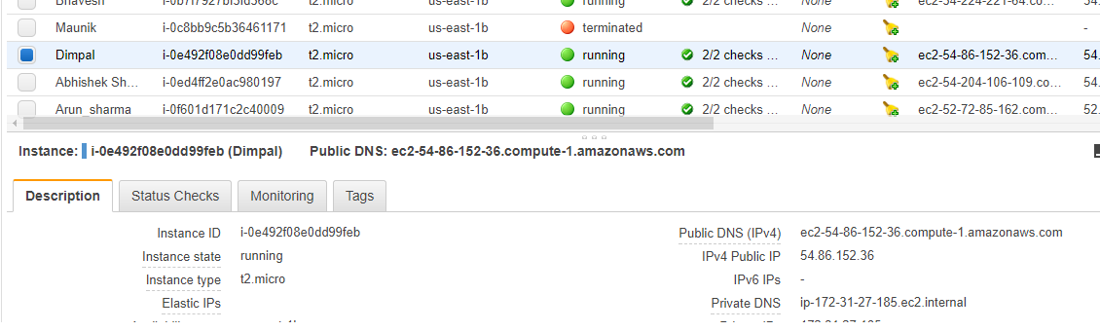

1. Click connect

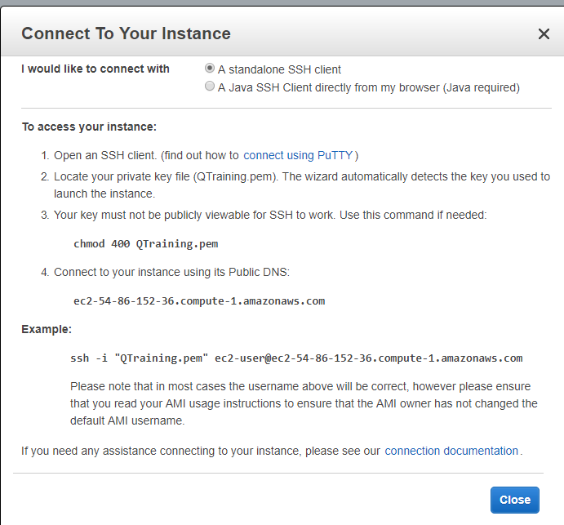

1. Click generate in puttygen and load pem file

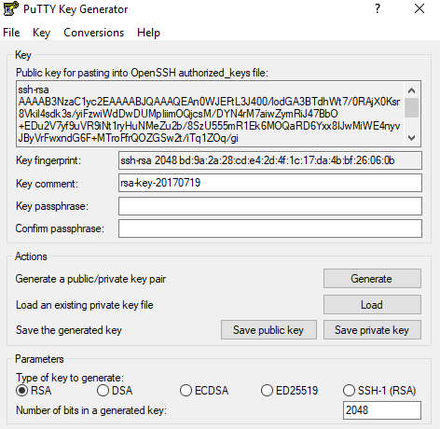

1. And Save private in your pc
2. Open putty and give host name as

ec2-user@ec2-54-86-152-36.compute-1.amazonaws.com

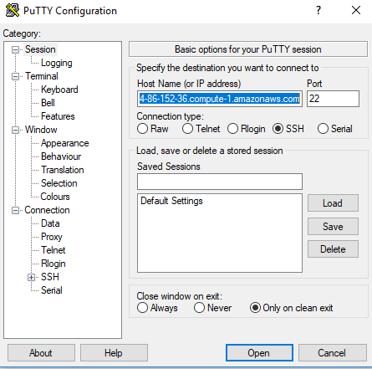

1. In the **Category** pane, expand **Connection**, expand **SSH**, and then select **Auth**. Complete the following:

upload the key file and click open

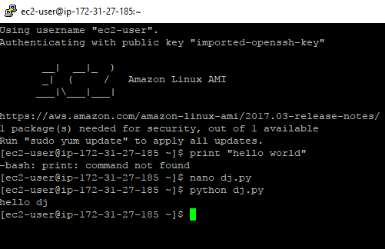

**Install a Web Server**

1. Enter this command in putty console(To get the latest bug fixes and security updates)

**sudo yum update –y**

1. After the updates complete, install the Apache web server with the PHP software package using the **yum install** command, which installs multiple software packages and related dependencies at the same time:

**sudo yum install -y httpd24 php56 php56-mysqlnd**

1. Start the web server with the command shown following:

**sudo service httpd start**

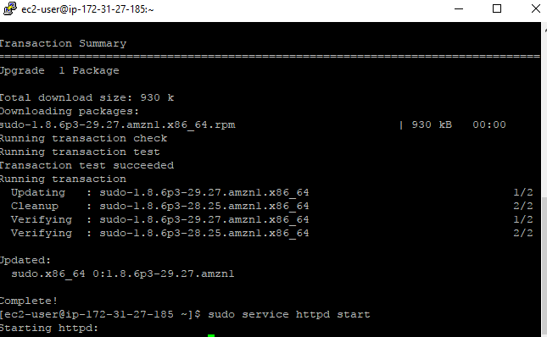

1. Select instance that you launch in this case it is Dimpal and in description click on defualt

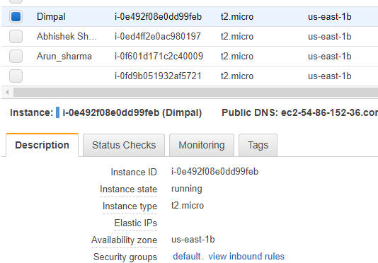

1. Click on Edit and Add Type as HTTP

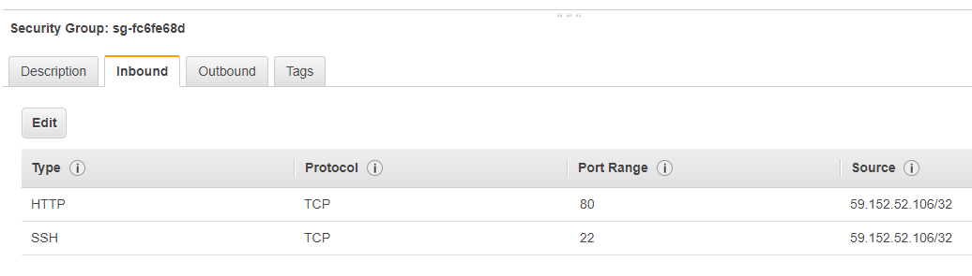

1. You can test that your web server is properly installed and started by entering the public DNS name of your EC2 instance in the address bar of a web browser, for example: <http://ec2-54-86-152-36.compute-1.amazonaws.com/>

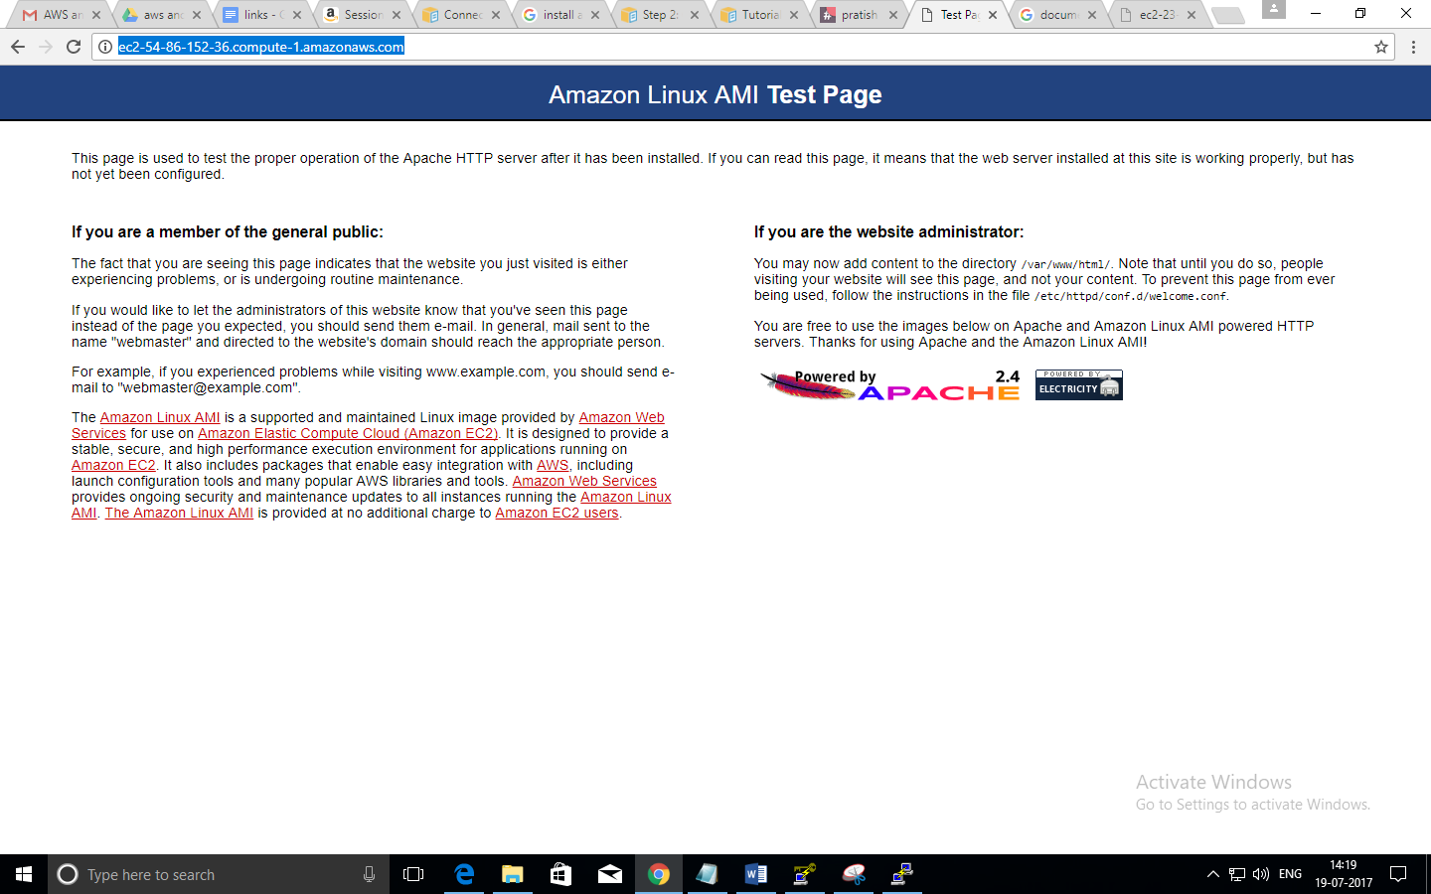

How to add content in the document root directory, /var/www/html?